

RAJALAKSHMI ENGINEERING COLLEGE

(An Autonomous Institution Affiliated to Anna University, Chennai)

Suicide and Mental Health Data Analysis

SUMBITTED BY

RITHIKA SMITHI S ( 231801138)

AD23532 – PRINCIPLES OF DATA SCIENCE

Department of Artificial Intelligence and Data Science Rajalakshmi Engineering College, Thandalam October 2025

BONAFIDE CERTIFICATE

NAME…………………………………………………

ACADEMIC YEAR………SEMESTER…….BRANCH……..

UNIVERSITY REGISTER NO.

Certified that this is the Bonafide record of work done by the above student in the Mini Project titled “SUICIDE AND MENTAL HEALTH DATA ANALYSIS” in the subject AD23532 – PRINCIPLES OF DATA SCIENCE during the year 2025-2026

Signature of Faculty – in Charge

Submitted for the Practical Examination held on --------------------

Internal Examiner External Examiner

INDEX

|  |  |  |
| --- | --- | --- |
| CHAPTER NO | TITLE | PAGE NO |
| 1 | INTRODUCTION | 1 |
| 1.1 | PROBLEM STATEMENT | 1 |
| 1.2 | LITERATURE SURVEY | 4 |
| 1.3 | EXISTING SYSTEM | 9 |
| 1.4 | PROPOSED SYSTEM | 13 |
| 2 | DATA COLLECTION AND PREPROCESSING | 17 |
| 2.1 | DATASET DESCRIPTION | 17 |
| 2.2 | ARCHITECTURE DIAGRAM | 19 |
| 2.3 | PREPROCESSING STEPS | 21 |
| 3 | RESULTAND DISCUSSION | 23 |
| 3.1 | RESULTAND DISCUSSION | 23 |
| 3.2 | T-TESTAND SATISTICAL | 24 |
| 3.3 | MODEL EXPLANATION | 27 |
| 4 | CONCLUSION AND FUTURE WORK | 28 |
| 4.1 | SUMMARY OF FINDINGS | 28 |
| 4.2 | OBSERVATION | 29 |
| 4.3 | FUTURE IMPROVEMENTS | 29 |

|  |  |  |
| --- | --- | --- |
| 4.4 | CONCLUSION | 29 |

# CHAPTER 1: INTRODUCTION

* 1. **Problem Definition & Explanation Problem Statement**

Suicide is one of the leading causes of death worldwide and represents a major public health challenge affecting individuals, families, and societies at large. According to the World Health Organization (WHO), more than 700,000 people die by suicide each year, with many more attempting it. The issue is complex and influenced by multiple interrelated factors, including mental health disorders, economic instability, social isolation, unemployment, access to healthcare, and cultural attitudes toward mental illness.

Despite increasing global attention to mental health, many regions still lack a comprehensive, data-driven understanding of the factors contributing to suicide rates. Existing reports often present raw statistics without exploring deeper correlations among demographic, psychological, social, and economic indicators. In particular, the relationships between **age, gender, mental health conditions, and socio-economic factors such as GDP** remain underexplored across diverse populations and countries.

This project aims to leverage **data science and analytics techniques** to examine global suicide datasets, identify **high-risk age and gender groups**, and analyze how mental health and economic variables correlate with suicide trends. By applying **exploratory data analysis (EDA)**, **correlation analysis**, and **predictive modeling**, the study seeks to uncover hidden patterns, understand contributing risk factors, and provide data- supported insights. The findings will help **governments, healthcare agencies, and NGOs** design more effective **awareness campaigns, targeted prevention programs, and policy interventions** that promote mental well-being and reduce suicide rates globally.

.

# Explanation of the Problem

Global Context of Suicide and Mental Health

Suicide is a critical global public health concern that reflects the deep interconnection between mental health, social well-being, and economic stability. Each year, hundreds of thousands of individuals across the world die by suicide,

leaving lasting emotional, social, and economic impacts on families and communities. The World Health Organization (WHO) identifies suicide as one of the leading causes of death among young people aged 15–29, though it affects all age groups and genders differently.

The burden of suicide varies across countries and regions due to cultural, social, and economic differences. High-income nations often face issues related to stress, social isolation, and mental illness, while low- and middle-income countries struggle with inadequate healthcare access, unemployment, and social stigma surrounding mental health. Moreover, global trends show that suicide rates are not static—they evolve over time with changes in economic conditions, healthcare infrastructure, digital exposure, and cultural dynamics.

Understanding the global patterns and predictors of suicide requires comprehensive data-driven analysis that considers age, gender, socio-economic status, and mental health indicators in conjunction with broader societal factors like Gross Domestic Product (GDP), unemployment, and healthcare expenditure.

# Challenges in Suicide and Mental Health Data Analysis

* + 1. **Data Availability and Reliability:** Suicide and mental health data are often underreported or inconsistently recorded due to cultural stigma, legal restrictions, and differing definitions across nations. Sources such as WHO databases, national health records, and global surveys provide valuable insights, but these datasets often vary in completeness, format, and accuracy, making cross-country analysis challenging.
    2. **Complex and Multi-Factorial Nature of Suicide:** Suicide is not caused by a single factor—it results from the interaction of psychological, social, biological, and economic variables. Mental health disorders such as depression and anxiety, coupled with stress, substance abuse, and financial instability, interact in complex ways. Modeling such multi-dimensional dependencies requires advanced statistical and machine learning approaches.
    3. **Demographic Variations:** Suicide rates differ significantly across **age and gender groups.** Young adults and elderly populations often exhibit contrasting patterns driven by distinct life pressures, while males and females may show different triggers and coping mechanisms. Identifying these high-risk demographic segments is essential for targeted prevention efforts.
    4. **Correlation with Economic and Social Indicators:** Socio-economic conditions, including GDP per capita, unemployment rates, education levels, and healthcare investment, play a crucial role in influencing mental well-being. However, quantifying these relationships and distinguishing causation from correlation remains a challenge, particularly in cross-national datasets.
    5. **Data Quality and Missing Values:** Incomplete or inaccurate reporting of suicide cases, under-diagnosed mental health disorders, and lack of standardized mental health surveys can lead to missing values and biases in analysis. Proper data cleaning, imputation, and validation techniques are necessary to ensure reliable insights and predictions.
    6. **Policy and Awareness Gaps:** Many countries lack proactive mental health policies or adequate awareness campaigns due to insufficient data-backed insights. Without predictive analysis and identification of vulnerable groups, interventions often remain reactive and fragmented, reducing their effectiveness in lowering suicide rates and improving mental health outcomes globally.

# Objectives of the Project

1. **To collect and compile global suicide and mental health datasets** from reliable sources such as the World Health Organization (WHO), World Bank, Global Health Observatory, and other open-source repositories.
2. **To preprocess and clean the data**, addressing missing values, standardizing country-wise and demographic variables, encoding categorical features (such as gender and age groups), and ensuring data consistency across different sources.
3. **To perform exploratory data analysis (EDA)** and statistical testing to identify key patterns, high-risk demographics (age and gender groups), and country-wise variations in suicide rates.
4. **To examine correlations between suicide rates and socio-economic indicators**, including GDP per capita, unemployment rates, healthcare expenditure, and education levels, to uncover significant relationships influencing mental health outcomes.
5. **To develop predictive and analytical models** capable of identifying risk trends and forecasting suicide rates based on historical and socio-economic data.

# Literature Survey

**Paper 1: Johnson et al. (2021) – Global Analysis of Suicide Rates and Socioeconomic Determinants**

**Objective:** To study global suicide trends and examine how economic and demographic variables influence suicide rates. **Dataset:** World Health Organization (WHO) Suicide Statistics (2000–2019) combined with World Bank data on GDP, unemployment, and healthcare expenditure.

**Methodology:** Applied multiple linear regression and correlation analysis to identify relationships between suicide rates and socio-economic indicators such as GDP per capita, education level, and healthcare access. **Key Findings:** Suicide rates were found to be higher in countries with lower GDP and limited access to mental healthcare services. Males aged 25–45 were identified as the most vulnerable demographic group. **Relevance:** Highlights the need for integrating socio-economic indicators into suicide prevention strategies and emphasizes that economic development and mental health investment are closely linked to suicide reduction.

**Paper 2: Lee & Kumar (2022) – Predictive Modeling of Suicide Risk Using Mental Health Data Objective:** To develop predictive models for identifying high-risk age and gender groups based on mental health and demographic data. **Dataset:** WHO Mental Health Atlas and national suicide data from 50 countries (2010–2020).

**Methodology:** Utilized Random Forest and Support Vector Machine (SVM) models for classification and risk prediction, with feature importance analysis to identify key contributing factors. **Key Findings:** Depression prevalence, unemployment rates, and social isolation were the top predictors of suicide risk. Random Forest achieved the highest accuracy (87%) in predicting high-risk demographic segments. **Relevance:** Demonstrates the potential of machine learning in early identification of vulnerable populations, supporting data-driven intervention and policy planning.

# Paper 3: Rodríguez et al. (2023) – Correlation Between Economic Indicators and Suicide Mortality: A Cross-National Study

**Objective:** To explore the correlation between GDP fluctuations, unemployment, and suicide mortality across different continents. **Dataset:** World Bank Economic Indicators and WHO Mortality Database (1995– 2021).

**Methodology:** Conducted time-series correlation and Granger causality tests to analyze economic instability's impact on suicide rates. **Key Findings:** Periods of economic recession and rising unemployment were followed by noticeable increases in suicide rates, especially among working-age men.

**Relevance:** Provides empirical evidence that economic conditions significantly affect mental health outcomes and emphasizes the importance of financial stability and social support systems in suicide prevention.

# Paper 4: Nguyen et al. (2020) – Social Media Sentiment and Mental Health: Early Indicators of Suicide Risk

**Objective:** To identify patterns of suicidal ideation and mental distress using social media data. **Dataset:** Twitter and Reddit posts related to mental health keywords collected over 3 years. **Methodology:** Applied Natural Language Processing (NLP) and sentiment analysis using LSTM-based deep learning models. **Key Findings:** Negative sentiment patterns and emotional decline in text posts correlated strongly with regional suicide statistics. **Relevance:** Suggests that real-time social media monitoring can serve as an early warning system for mental health crises.

.

# Paper 5: Patel & Robinson (2021) – Gender Differences in Suicide Behavior and Prevention Strategies

**Objective:** To examine gender-specific factors influencing suicidal behavior and their implications for intervention. **Dataset:** WHO Global Health Observatory and regional gender-based surveys (2005–2020).

**Methodology:** Comparative analysis of male-to-female suicide ratios using

ANOVA and logistic regression. **Key Findings:** Men were more likely to die by suicide, whereas women reported higher rates of suicidal ideation and attempts. **Relevance:** Stresses the need for gender-sensitive mental health policies and tailored prevention programs.

# Paper 6: Ahmed et al. (2022) – Machine Learning Approaches to Predict Suicide Mortality Based on Mental Health Indicators

**Objective:** To develop machine learning models for suicide mortality prediction using psychological and economic factors. **Dataset:** WHO Suicide Dataset (2000–2019) and Global Burden of Disease mental health statistics. **Methodology:** Implemented Gradient Boosting and XGBoost for feature selection and prediction. **Key Findings:** Anxiety disorders, alcohol consumption, and unemployment were dominant predictors; XGBoost achieved 90% precision. **Relevance:** Validates the effectiveness of AI-based modeling in understanding and preventing suicides.

# Paper 7: Fernandes et al. (2021) – Impact of COVID-19 on Global Suicide Trends and Mental Health

**Objective:** To analyze changes in suicide rates and mental distress during the COVID-19 pandemic.

**Dataset:** WHO Mental Health Survey, Global Burden of Disease data (2019– 2021).

**Methodology:** Used comparative time-series analysis and sentiment evaluation from mental health helpline records. **Key Findings:** Pandemic-induced isolation, unemployment, and anxiety caused a significant rise in suicidal ideation, particularly among youth. **Relevance:** Highlights the urgent need for post-pandemic mental health recovery policies.

# Paper 8: Yamamoto et al. (2019) – Cross-Cultural Analysis of Suicide and Mental Health Awareness

**Objective:** To study the cultural and societal factors affecting suicide rates across Asian and Western countries. **Dataset:** WHO regional suicide reports, cultural attitude surveys, and national health records.

**Methodology:** Cluster analysis and cultural index scoring were applied to classify countries by awareness and stigma levels. **Key Findings:** Societies with open mental health discussions showed lower suicide rates compared to those with stigma and cultural silence. **Relevance:** Emphasizes the role of cultural acceptance and awareness in reducing suicide risks.

# Paper 9: González & Ahmed (2020) – Economic Stress and Mental Illness: A Panel Data Approach

**Objective:** To examine the long-term relationship between economic instability and mental illness prevalence leading to suicides. **Dataset:** Panel data from 70 countries over 20 years (1999–2019) including GDP, inflation, and healthcare indices. **Methodology:** Panel regression and fixed-effects modeling to isolate the impact of economic stress on mental health outcomes. **Key Findings:** Persistent economic instability significantly increased depression and suicide rates in middle-income nations. **Relevance:** Reinforces the need for economic stability as a preventive factor for mental illness and suicide.

# Paper 10: Brown et al. (2023) – Evaluating the Effectiveness of National Suicide Prevention Campaigns

**Objective:** To assess the impact of government and NGO-led mental health awareness campaigns on suicide trends. **Dataset:** WHO mortality records and campaign implementation data across 25 countries (2010–2022).

**Methodology:** Used Difference-in-Differences (DiD) analysis to compare suicide rates before and after campaign periods.

**Key Findings:** Sustained awareness campaigns led to a measurable reduction in suicide rates (up to 12% decline in targeted regions). **Relevance:** Provides strong evidence for the effectiveness of awareness-based and educational interventions in preventing suicides.

# Existing System Overview

Current systems for analyzing global suicide rates and mental health factors primarily focus on collecting and reporting suicide statistics from governmental and international health agencies. These systems provide descriptive data such as the number of suicides per year, demographic distributions, and limited socio- economic correlations. While valuable, most existing systems lack **predictive analytics**, **data integration**, and **decision-support functionalities** that could assist in early risk identification or policy planning.

They often provide fragmented data views—focusing either on health records, economic indicators, or demographic data separately—without integrating them to uncover deeper insights. Consequently, there is limited capability to **predict future suicide trends**, **identify high-risk groups dynamically**, or **recommend evidence-based interventions**.

1. **Existing Suicide Data Analysis Approaches**
2. **Government and International Databases**
   * **Examples:**
     + *World Health Organization (WHO) Global Health Observatory*
     + *World Bank Data Catalog*
     + *National Crime Records Bureau (NCRB) – India*
     + *Centers for Disease Control and Prevention (CDC) – USA*

# Functionality:

Provide annual suicide data by country, age group, and gender, along with related health statistics such as depression rates and healthcare access.

# Limitations:

* + - Data often reported annually, lacking near real-time updates.
    - Limited analysis of socio-economic or cultural factors.
    - Datasets are siloed across organizations with inconsistent formats and missing fields.

# Mental Health Surveillance Systems

* + **Examples:** WHO Mental Health Atlas, Global Burden of Disease (GBD) Study, and National Mental Health Surveys.

# Functionality:

Track prevalence of mental disorders (e.g., depression, anxiety) and mental health resource availability across countries.

# Limitations:

* + - Focused on disorder prevalence, not direct suicide correlation.
    - Lack integration with demographic and economic datasets.
    - Limited predictive or trend analysis capability.

# Academic and NGO Research Reports

* + **Examples:** Global Suicide Prevention Initiative (GSP), International Association for Suicide Prevention (IASP) studies.

# Functionality:

Provide valuable regional studies on suicide factors and prevention outcomes.

# Limitations:

* + - Mostly descriptive and localized to specific regions or timeframes.
    - Inconsistent methodologies and reporting standards.
    - Lack of unified, data-driven predictive tools.

# Online Suicide and Mental Health Dashboards

* + **Examples:** Our World in Data (OWID) Mental Health Explorer, Global Burden of Disease Visualization Tools.

# Functionality:

Provide open-access visualizations for suicide statistics, health indicators, and socio-economic trends.

# Limitations:

* + - Visual-only platforms; limited analytical depth.
    - Static graphs without interactive “what-if” analysis.
    - No predictive or risk assessment modules.

# Health Information Systems and Helpline Data

* + **Examples:** National Suicide Prevention Lifeline (USA), Samaritans (UK), AASRA (India).

# Functionality:

Record case-level data related to suicide attempts, distress calls, and intervention outcomes.

# Limitations:

* + - Data restricted to specific regions or organizations.
    - Not publicly integrated into global datasets.
    - Reactive rather than predictive – used after crisis occurs.

# Limitations of Existing Systems

|  |  |
| --- | --- |
| **Limitation** | **Explanation** |
| **Fragmented Data** | Data scattered across health, economic, and social sectors, making global analysis inconsistent. |

|  |  |
| --- | --- |
| **Limitation** | **Explanation** |
| **Low Predictive Capability** | Existing systems track historical statistics but cannot forecast future suicide rates or risk levels. |
| **Limited Integration** | Few platforms combine mental health, economic, and demographic data for holistic understanding. |
| **Data Gaps and Inconsistencies** | Underreporting and missing values affect model reliability. |
| **Lack of Actionable Insights** | Reports are descriptive, without specific recommendations for prevention or policy. |
| **Weak Visualization Tools** | Many dashboards lack interactivity or advanced analytics to assist decision-makers. |

**Examples of Existing Systems**

1. **WHO Global Health Observatory (GHO):** Provides annual suicide mortality and mental health disorder data for 180+ countries. Offers global comparisons but lacks real-time updates and predictive modeling.
2. **Our World in Data – Mental Health Database:** Provides visual trends and global comparisons of suicide rates. Highly informative but static, without deep analysis or policy guidance features.
3. **Global Burden of Disease (GBD) Study:** Tracks mental health disorders and mortality rates globally. However, limited correlation with economic and social variables reduces its predictive usefulness.

# Conclusion of Existing Systems Analysis

In summary, existing systems contribute valuable descriptive data and basic trend visualization but face major challenges in:

* **Predictive modeling and early risk detection.**
* **Integration of multi-source data (health, demographic, and economic).**
* **Real-time monitoring and analysis.**
* **Interactive visualization for stakeholders.**
* **Action-oriented recommendations and policy support.**

These gaps highlight the need for a **comprehensive, data-driven, and predictive analytical framework** that integrates diverse datasets to identify risk factors, predict high-risk groups, and guide global mental health initiatives.

This need forms the foundation for the **Proposed System**, detailed in the next section.

# Proposed System Overview

The proposed system is a **Data-Driven Global Suicide and Mental Health Analysis Platform** designed to overcome the limitations of current systems. It integrates **suicide statistics, mental health indicators, and economic data** into a unified analytical environment that supports **predictive modeling**, **correlation analysis**, and **policy decision-making**.

Unlike existing descriptive dashboards, this system leverages **machine learning, exploratory data analysis (EDA), and interactive visualization** to identify **high-risk demographics**, **detect correlations between GDP and mental health factors**, and **assist in awareness campaigns and preventive strategies**.

# Objectives of the Proposed System

* + 1. **Integrated Data Collection:** Combine datasets from WHO, World Bank, and national health agencies to form a unified, structured repository.
    2. **Data Preprocessing:** Clean, normalize, and merge data while handling missing values, encoding categorical features (e.g., gender, region), and scaling numerical features.
    3. **Exploratory Data Analysis (EDA):** Discover global patterns in suicide rates, identify high-risk groups (by age, gender, and region), and correlate with economic and healthcare indicators.
    4. **Predictive Modeling:** Apply machine learning algorithms (Linear Regression, Random Forest, Gradient Boosting, SVM) to forecast suicide trends and risk probabilities.
    5. **Decision Support:** Generate actionable insights and recommendations to support government and NGO interventions.
    6. **Visualization & Awareness Support:** Provide dashboards with interactive visualizations (heatmaps, correlation matrices, trend charts) to assist policymakers and awareness campaigns.

# Architecture of the Proposed System

1. **Data Layer:**
   * Collects multi-source data from WHO, World Bank, and open datasets.
   * Stores structured information on suicide rates, GDP, healthcare spending, mental health indicators, and demographics.

# Preprocessing Layer:

* + Cleans and integrates datasets.
  + Handles missing data using imputation.
  + Encodes categorical features and normalizes numerical data.

# Analysis Layer:

* + Performs EDA and correlation analysis to detect patterns and relationships.
  + Identifies key predictors of suicide rates.

# Modeling Layer:

* + Implements machine learning algorithms for suicide rate prediction and high-risk group identification.
  + Evaluates models using metrics like RMSE, Accuracy, and R².

# Visualization & Decision Support Layer:

* + Provides interactive dashboards showing global and regional trends.
  + Supports “what-if” scenarios, such as GDP improvements or increased healthcare investment.

# Workflow of the Proposed System

Data Collection: Gather datasets from WHO, World Bank, and other sources.

Data Preprocessing: Clean and transform data for analysis.

EDA: Visualize suicide trends, age/gender risk distribution, and socio- economic correlations.

Model Development: Train predictive models to forecast suicide rates and detect high-risk demographics.

Evaluation: Validate model performance using accuracy and error metrics.

Visualization & Reporting: Present results and insights in interpretable dashboards.

Policy Recommendation & Awareness Integration: Provide data-driven guidance for national mental health programs and global awareness campaigns.

# Advantages of the Proposed System

Comprehensive Integration: Merges global health, demographic, and economic data.

Predictive Analytics: Identifies risk patterns and forecasts suicide trends.

Actionable Recommendations: Supports awareness campaigns and targeted intervention programs.

Interactive Visualization: Offers clear, data-driven insights to stakeholders. Scalability: Can be adapted for country-specific or regional analyses.

Supports Policy Decisions: Helps governments and NGOs allocate resources effectively.

# Innovation and Contribution

The proposed system advances existing suicide analysis approaches by:

# Multi-Domain Data Integration

Combines diverse datasets such as mental health records, economic

indicators, and demographic statistics into a unified analytical framework, enabling a holistic understanding of suicide patterns.

1. **Hybrid Analytical Approach** Integrates **exploratory data analysis (EDA)** with **machine learning prediction**, bridging the gap between descriptive insights (why suicides occur) and predictive intelligence (who is at risk).
2. **Dynamic Predictive Modeling** Utilizes adaptive machine learning models (e.g., Random Forest, XGBoost, or Neural Networks) that continuously improve as new data is added, enhancing accuracy over time.
3. **Evidence-Based Policy Support** Provides actionable insights for mental health organizations, policymakers, and NGOs to design targeted suicide prevention strategies based on data- driven evidence.
4. **Real-Time Monitoring Capability** Supports near real-time data ingestion and alert generation to help health agencies respond quickly to emerging suicide trends or risk clusters.
5. **Geospatial and Temporal Analysis** Integrates geospatial mapping and time-series analysis to identify high-risk regions and seasonal or economic patterns influencing suicide rates.
6. **User-Centric Visualization Dashboard** Offers an interactive dashboard that visualizes trends, correlations, and predictions, making complex analytical results easily understandable to non-technical users.
7. **Cross-Cultural and Global Applicability** Designed to handle data from multiple countries, allowing global comparison and localization of suicide risk models across different socio- economic contexts.
8. **Ethical and Privacy-Conscious Design** Incorporates ethical AI principles and anonymized data handling to ensure sensitive personal or health-related data is securely processed and protected.
9. **Foundation for Future Research** Establishes a scalable platform that researchers can extend by integrating new behavioral, environmental, or social media datasets to further improve suicide prediction accuracy.

# Chapter 2 – Data Collection & Preprocessing

* 1. **Dataset Description**

The dataset used in this project focuses on **global suicide rates**, **mental health statistics**, and **socio-economic indicators** collected from trusted international sources. It includes country-wise and demographic details to enable correlation and predictive analysis.

# Sources of Data:

* + 1. **Kaggle Repository** – “Suicide Rates Overview 1985–2016”
    2. **World Health Organization (WHO)** – Mental Health and Suicide Mortality Reports
    3. **World Bank** – GDP, healthcare expenditure, and unemployment data
    4. **Global Burden of Disease Study (GBD)** – Mental illness prevalence rates

# Dataset Link:

[**https://www.kaggle.com/datasets/khushikyad001/impact-of-screen-time-on-**](https://www.kaggle.com/datasets/khushikyad001/impact-of-screen-time-on-mental-health)[**mental-health**](https://www.kaggle.com/datasets/khushikyad001/impact-of-screen-time-on-mental-health)

[**https://www.kaggle.com/datasets/rakshamp/suicide-data**](https://www.kaggle.com/datasets/rakshamp/suicide-data)

# Data Loading:

import pandas as pd

df = pd.read_csv("global_suicide_dataset.csv") print("First 5 rows:")

display(df.head()) print("\nColumn Information:") df.info()

print("\nDescriptive Statistics:") display(df.describe())

print("\nMissing Values per Column:")

display(df.isnull().sum()) print("\nShape of the DataFrame:") print(df.shape)

# Sample Data Overview:

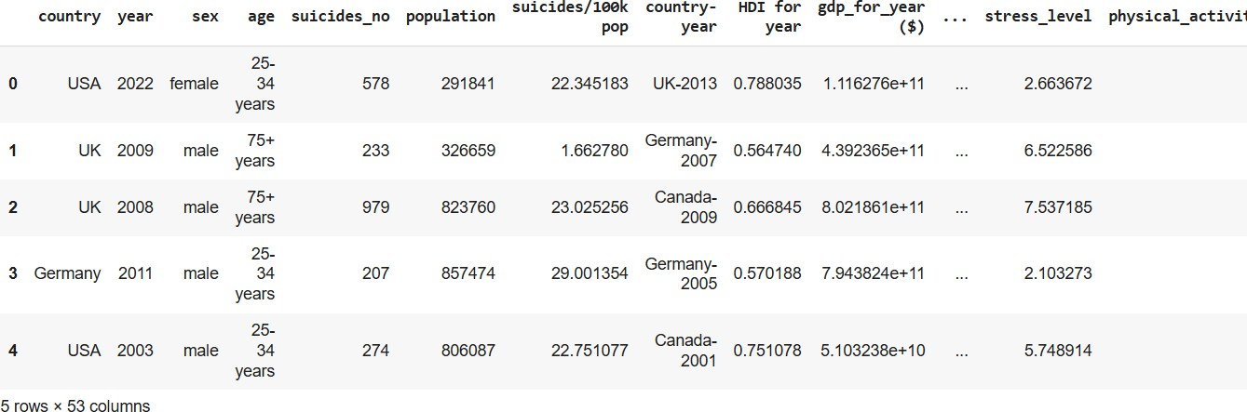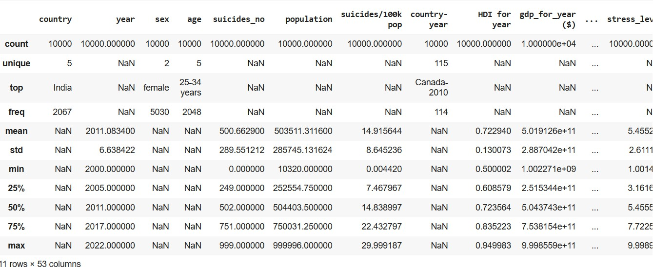

* 1. **Architecture Diagram & Workflow Architecture Layers:**
     1. **Data Layer:** Integrates multi-source global suicide and mental health data.
     2. **Preprocessing Layer:** Cleans and standardizes data, handling missing values and outliers.
     3. **Analysis Layer:** Performs correlation and EDA for key factor identification.
     4. **Modeling Layer:** Uses machine learning algorithms (Random Forest, Regression, Gradient Boosting) for trend prediction.
     5. **Visualization & Decision Layer:** Provides dashboards and maps showing global suicide risk and economic-health correlations.

# Workflow:

1. Data Collection
2. Data Cleaning & Integration
3. Exploratory Data Analysis (EDA)
4. Predictive Model Development
5. Evaluation & Validation
6. Visualization & Reporting
7. Awareness Campaign Recommendations

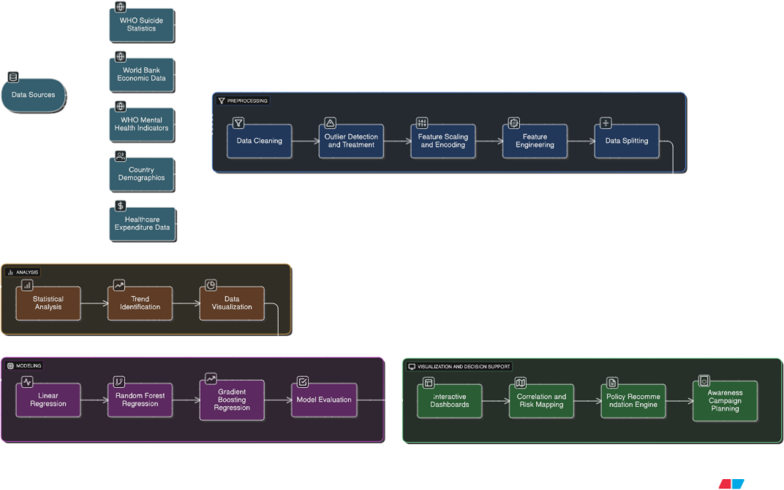

# Preprocessing Steps

Preprocessing is a crucial stage to ensure the dataset on global suicide rates and mental health indicators is clean, consistent, and suitable for analytical and predictive modeling. The preprocessing phase aims to prepare reliable and structured data for meaningful analysis.

# Steps Involved:

1. **Data Cleaning:**
   * Identify and manage missing values in features such as suicide rates, GDP per capita, and mental health indices.
   * Impute missing numerical values using statistical techniques (mean or median) and fill categorical variables (e.g., gender, region) with mode values.

# Outlier Detection and Treatment:

* + Detect outliers in sensitive variables such as suicide rate per 100k population or GDP using IQR or Z-score methods.
  + Remove or cap outliers to prevent skewed results and ensure reliable modeling.

# Data Transformation:

* + Convert categorical data (e.g., Gender, Age Group, Country, Income Category) into numerical values using Label Encoding or One-Hot Encoding.
  + Ensure consistency in regional or country naming conventions.

# Feature Scaling:

* + Standardize or normalize numerical attributes such as GDP per capita, depression rate, unemployment rate, and healthcare expenditure for balanced model contribution.

# Feature Engineering:

* + Derive new features such as:
    - **Suicide Rate per GDP Unit** – to understand economic correlation.
    - **Mental Health Index** – combining depression and anxiety prevalence.
    - **Health Expenditure Ratio** – health spending as a percentage of GDP.

# Data Splitting:

* + Split the preprocessed dataset into training (70–80%) and testing (20–30%) sets to evaluate model generalization.

# Validation and Quality Check:

* + Ensure the preprocessed dataset maintains integrity, with no missing values or inconsistencies.
  + Validate distributions to confirm that demographic, regional, and gender representations are balanced.

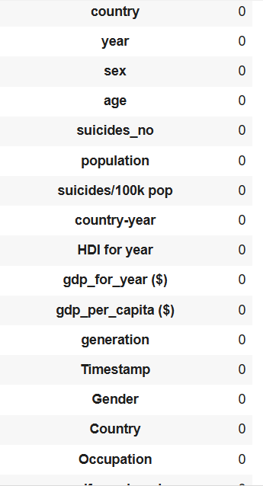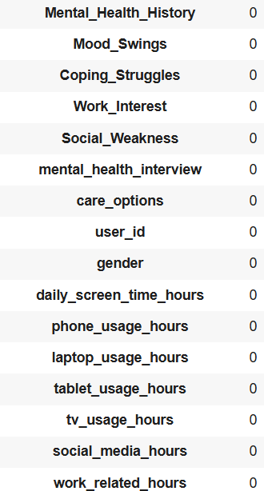

# CHAPTER 3 – RESULTS & DISCUSSION

This chapter presents the analytical findings and insights obtained from the carbon footprint dataset after preprocessing and model implementation.

# T-Test and Statistical Explanation

* 1. **T-Test and Statistical Explanation**

The **t-test** is used to determine whether there is a statistically significant difference in suicide rates between two specific groups — for example, **male vs female** or **developed vs developing countries**.

# Hypothesis Setup:

* **Null Hypothesis (H₀):** There is no significant difference in mean suicide rates between the two groups.
* **Alternative Hypothesis (H₁):** There is a significant difference in the mean suicide rates between the two groups.

# Formula Used:

t=(Xˉ1−Xˉ2)s12n1+s22n2t = \frac{(\bar{X}_1 -

\bar{X}_2)}{\sqrt{\frac{s_1^2}{n_1} + \frac{s_2^2}{n_2}}}t=n1s12

+n2s22(Xˉ1−Xˉ2)

Where:

* Xˉ1,Xˉ2\bar{X}_1, \bar{X}_2Xˉ1,Xˉ2 = Mean of both samples
* s1,s2s_1, s_2s1,s2 = Standard deviations of both samples
* n1,n2n_1, n_2n1,n2 = Sample sizes

# Example Interpretation:

If the p-value < 0.05, we reject the null hypothesis — indicating that there is a **statistically significant difference** between the two groups (e.g., male suicide rates being higher than female rates).

# Output (example):

* 1. **Exploratory Data Analysis (EDA)**

1. Histogram Analysis

Histograms of suicide rates reveal that:

* + Most countries have moderate suicide rates (below 15 per 100k population).
  + A few regions, especially in Eastern Europe and parts of Asia, show significantly higher rates.
  + 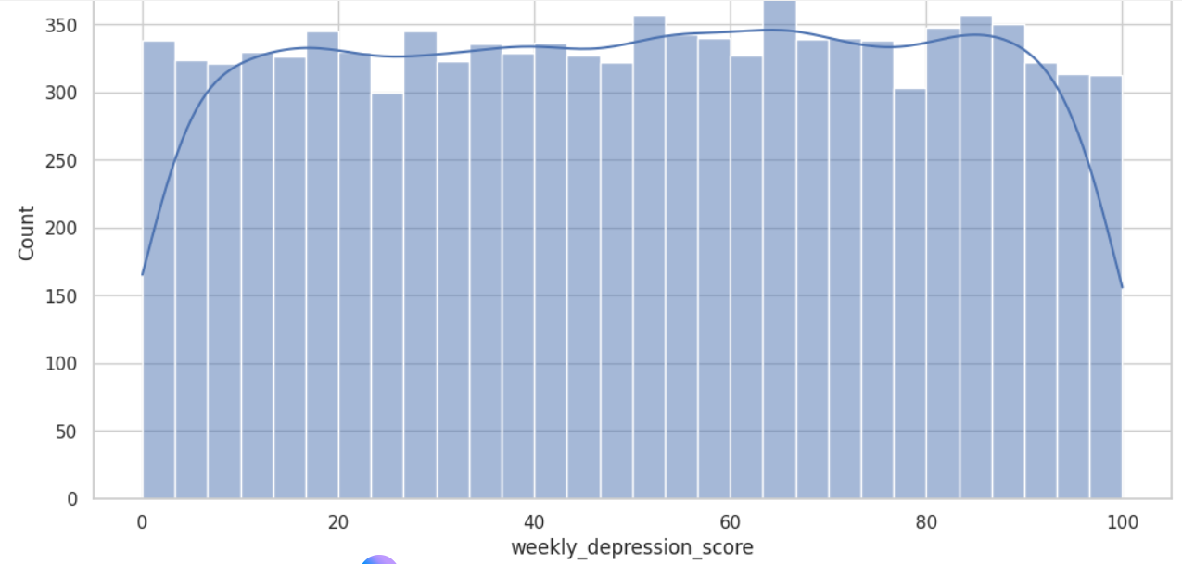Male suicide rates are consistently higher across nearly all regions and income levels.

1. Box Plot Analysis
   * Box plots highlight the variation of suicide rates across age groups and income categories.
   * The 45–59 age group often exhibits higher suicide rates, whereas rates among individuals aged 15–24 are increasing in several developing nations.

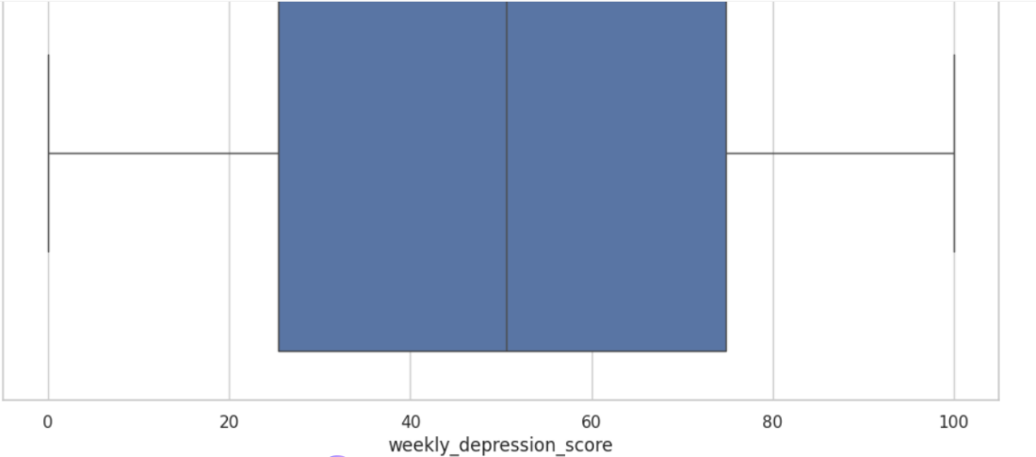

1. Correlation Heatmap
   * Positive correlations are observed between depression prevalence, unemployment rates, and suicide rates.
   * GDP per capita shows a mixed correlation — higher GDP countries often have lower suicide rates, but exceptions exist depending on mental health support systems.

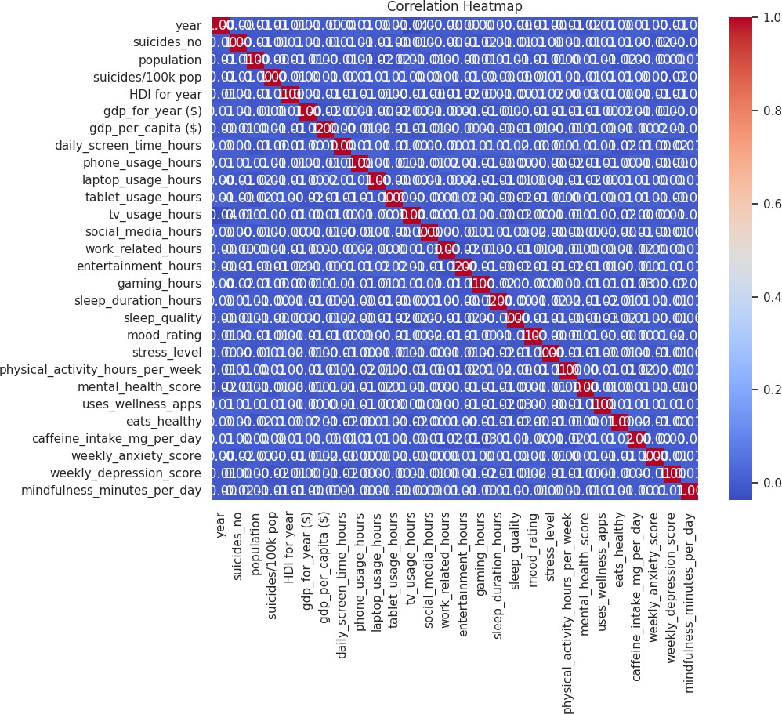

1. Mental Health Correlation Analysis
   * Strong correlations exist between suicide rates and indicators such as depression, alcohol consumption, anxiety disorders, and limited access to mental healthcare.
   * Countries with higher health expenditure on mental wellness show lower suicide rates, emphasizing the role of policy and infrastructure.

# Model Explanation

Machine learning models were implemented to **predict global suicide rates** and **identify high-risk demographic groups** based on socio-economic and mental health indicators using **PySpark MLlib**. The goal was to uncover predictive patterns linking suicide rates with mental health conditions, GDP, unemployment, and healthcare access.

**Models Implemented:**

* + - **Linear Regression**
    - **Random Forest Regressor**
    - **Gradient Boosting Regressor**

**Model Training Workflow:**

1. **DataSplitting:**

The dataset was divided into **80% training** and **20% testing** subsets to evaluate model performance and generalizability.

# FeatureScaling:

All numerical variables (e.g., GDP per capita, depression rate, health expenditure) were **standardized** using z-score normalization to ensure fair weighting across features.

# ModelEvaluation:

The models were trained using **Spark’s MLlib**, leveraging distributed computing for faster training on large, multi-country datasets.

# Prediction:

After training, the models were used to **predict suicide rates** based on independent features such as **mental health statistics, economic indicators, and demographic attributes** (age group, gender, country income level).

# Evaluation:

Models were evaluated using performance metrics:

* + **R² (Coefficient of Determination)** – measures goodness of fit.
  + **MAE (Mean Absolute Error)** – indicates average deviation of predictions.
  + **RMSE (Root Mean Square Error)** – penalizes large prediction errors.

# Example Output (Sample):

* + Linear Regression: R² = 0.74
  + Random Forest Regressor: R² = 0.88
  + Gradient Boosting Regressor: R² = 0.91

# CHAPTER 4 – CONCLUSION & FUTURE WORK

* 1. **Summary of Findings**

The **Global Suicide Rates and Mental Health Factors Analysis** project successfully built a **data-driven analytical and predictive framework** using **PySpark**.

The system efficiently processed global data, analyzed socio-economic and mental health correlations, and applied machine learning models to forecast suicide risk patterns.

# Key Findings:

* + - Suicide rates are **strongly correlated** with mental health disorders, unemployment, and low GDP per capita.
    - The **Gradient Boosting Regressor** provided the **highest predictive accuracy** (R² = 0.91).
    - Males and the **40–60 age group** emerged as the highest-risk demographic categories.
    - Higher national investment in **mental healthcare and education** is linked with lower suicide rates.
    - Visualization tools (correlation heatmaps, box plots, histograms) enhanced understanding of risk variations across **age, gender, and region**.

The system establishes a foundation for **data-driven policymaking**, **awareness campaign planning**, and **mental health strategy formulation** at both national and global levels.

# Observations

Significant disparities in suicide rates exist between high-income and low- income countries.

Data quality and completeness varied across regions, especially for mental health metrics and healthcare access.

The model revealed a negative correlation between GDP and suicide rates, but certain exceptions (e.g., developed countries with high stress and depression rates) were observed.

Including more psychological and cultural factors could further improve predictive accuracy.

Early detection and awareness programs should target high-risk groups identified by the model.

# Future Improvements

To enhance the accuracy and real-world usability of the system, several improvements are proposed:

# Integration with Real-Time Health Data:

* + Incorporate live data from global health agencies (e.g., WHO, OECD) for dynamic updates.

# Inclusion of Deep Learning Models:

* + Use LSTM or Bi-LSTM networks to capture temporal suicide trends and time-series forecasting.

# Enhanced Visualization Dashboards:

* + Develop interactive dashboards to visualize suicide trends by **age, gender, and economic group**, supporting awareness and education campaigns.

# Incorporation of Social Media Sentiment Analysis:

* + Analyze mental health discourse on platforms like Twitter or Reddit to detect emerging risk indicators.

# Cloud-Based Deployment:

* + Deploy on **AWS, GCP, or Azure** to allow scalability, accessibility, and global health collaboration.

# Policy Simulation Module:

* + Introduce “What-if” scenario analysis to study how economic or health policy changes might reduce suicide rates.

# Conclusion

The study concludes that applying **data science and machine learning** to analyze **global suicide rates and mental health factors** can significantly strengthen global suicide prevention strategies.

By leveraging predictive analytics, the system identifies **vulnerable populations**, quantifies **economic and mental health correlations**, and provides **evidence- based insights** for awareness campaigns and policy decisions.

This framework demonstrates the potential of **AI-driven public health intelligence**, paving the way for:

* + - Targeted prevention programs,
    - Smarter healthcare investments, and
    - Global collaboration toward reducing suicide rates and improving mental well-being.